**PROJECT DESIGN PHASE-II**

**TECHNOLOGY STACK**

**CHILD SAFETY AND MONITORING GADGET**

Technical Architecture:

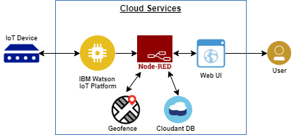

Table 1:Components and Technologies:

|  |  |  |  |
| --- | --- | --- | --- |
| S.No | component | Description | Technology |
| 1 | User interface | Interact with gadgets by using Mobile | Web UI |
| 2 | Application Logic-1 | By sending keywords or SMS such as location ,image via mobile | python |
| 3 | Application Logic-2 | Receive location and surrounding image of children | IBM watson |
| 4 | Cloud database | Data base service on cloud | IBM cloudant |

Table-2: Application Characteristics:

|  |  |  |  |
| --- | --- | --- | --- |
| S.No | Characteristics | Description | Technology |
| 1. | Open source frame works | Smart wearable device, iot setup , programming iot device , text service, sending information via cloud | Cloud DB, web UI |
| 2. | Security implementations | Implementing security by means of encryption | SHA-256  Encryption |
| 3. | Scalable Architecture | Gadget can tell even heat beat of child, SOS light alert people | Cloudant DB , web UI |
| 4. | Availability | Available for 24/7 | Ibm Watson IOT platform ,node red, ibm cloud |
| 5. | Performance | Accuracy in finding location ,efficient ,alert public by buzzer | Web UI, cloudant DB, Geofence, ibm Watson IOT platform |